**Sprint 3**

|  |  |
| --- | --- |
| Date | 12 November 2022 |
| Project Name | IOT Based Safety Gadget for Child Safety Monitoring and Notification |

Sprint 3 is adding the geofence and changing the geo fence when need

# Coding :

package com.example.geofence; import android.app.PendingIntent; import android.content.Context;

import android.content.ContextWrapper; import android.content.Intent;

import android.widget.Toast;

import com.google.android.gms.common.api.ApiException; import com.google.android.gms.location.Geofence;

import com.google.android.gms.location.GeofenceStatusCodes; import com.google.android.gms.location.GeofencingRequest; import com.google.android.gms.maps.model.LatLng;

public class GeofenceHelper extends ContextWrapper {

private static final String *TAG* = "GeofenceHelper"; PendingIntent pendingIntent;

public GeofenceHelper(Context base)

{super(base);

}

public GeofencingRequest getGeofencingRequest(Geofence geofence)

{return new GeofencingRequest.Builder()

.addGeofence(geofence)

.setInitialTrigger(GeofencingRequest.*INITIAL_TRIGGER_ENTER*)

.build();

}

public Geofence getGeofence(String ID, LatLng latLng, float radius, int transitionTypes) {

return new Geofence.Builder()

.setCircularRegion(latLng.latitude, latLng.longitude,

radius)

}

.setRequestId(ID)

.setTransitionTypes(transitionTypes)

.setLoiteringDelay(5000)

.setExpirationDuration(Geofence.*NEVER_EXPIRE*)

.build();

public PendingIntent getPendingIntent()

{if (pendingIntent != null) { return pendingIntent;

}

Intent intent = new Intent(this, GeofenceBroadcastReceiver.class); pendingIntent = PendingIntent.*getBroadcast*(this, 2607, intent,

PendingIntent.*FLAG_IMMUTABLE*);

return pendingIntent;

}

public String getErrorString(Exception e)

{if (e instanceof ApiException) {

ApiException apiException = (ApiException) e; switch (apiException.getStatusCode()) {

case GeofenceStatusCodes

.*GEOFENCE_NOT_AVAILABLE*: return "GEOFENCE_NOT_AVAILABLE";

case GeofenceStatusCodes

.*GEOFENCE_TOO_MANY_GEOFENCES*: return "GEOFENCE_TOO_MANY_GEOFENCES";

case GeofenceStatusCodes

.*GEOFENCE_TOO_MANY_PENDING_INTENTS*: return "GEOFENCE_TOO_MANY_PENDING_INTENTS";

}

}

return e.getLocalizedMessage();

}

}

# Output :

**Adding Geofence page**

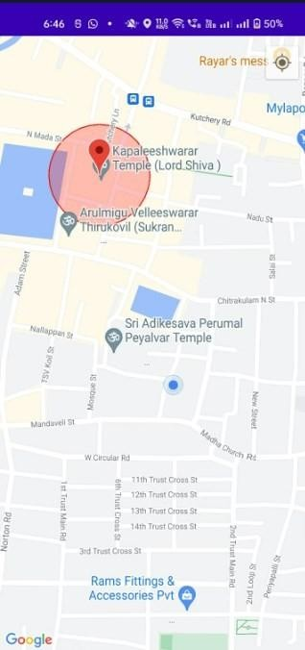

Geofence Location

My Location